Name ________________________________________ Sect ____8__________________ Weekly Math Maintenance # 31
Simplify the expression -3b – 4c for the values b = -7 and c = -1 | Find the measure of the missing side:  A = 2.5 in B = 6 in  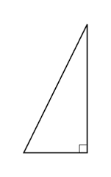 | What is the solution to the linear system:  y = 2x – 18  -2x – 3y = 14 | A triangle with the points (9, 2),  (4, -3), and (0, 6) is reflected across the y axis. What are the new coordinates?
Scrambled: Use all four of the number set to create the first number. You must use each number once and only once, and you can use any combination of the four basic operations (+, -, x, ÷)  28: 1, 2, 7, 9 | Solve for g:  3(2g – 4) = 4g + 20 | Add:  .37 + $\frac{2}{5}+4\frac{1}{4}$ | Doreen has a coupon for 20 percent off at Kohl’s. She wants to purchase a shirt that normally sells for $12.60, a pair of shoes that normally sells for $32.60, and a hat that normally sells for $18.00. If she uses the coupon and pays with a $50 bill and a $20 bill, how much change will she receive?
Draw a line with the equation  y = $-\frac{5}{3}$x + 4  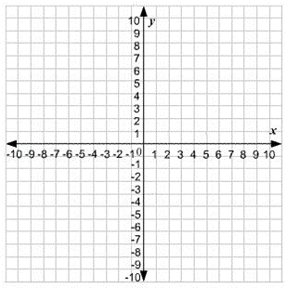 | Find the volume:  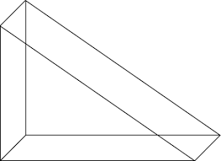  B = 6 in, Tri H = 8 in, PrH = 2.8 in | Find the surface area  L = 4.5 cm, W = 3.2 cm, H = 11 cm | Brain Teaser: A box of marbles contains 25 marbles: 11 red, 11 blue, and 3 green. Another 11 marbles are added to the box, and the likelihood of drawing a green marble is now greater than the likelihood of drawing a red marble, but less than the likelihood of drawing a blue marble. How many of each color marbles were added to the box?
Evaluate:  (8.084 • 10⁷) ÷ (2.02 • 10⁹) | Simplify:  $\frac{x^{5}y^{9} z^{7}}{x^{6} y^{9} z^{3}}$ | Solve for z:  $\frac{2}{3}z-\frac{3}{4}=2\frac{1}{4}$ | Tony catches 19 fish while fishing for 6 hours and 20 minutes. If he continues to catch fish at the same rate the next time he goes fishing, how many fish would he catch if he fishes for 4 hours?

