Name ______________________________________ Sect ________________
Scatterplot HW

The table below compares the cost of a pair of dress shoes with the expected length of time they will last. Use the table to answer the questions.

Cost (x) $15 $20 $10 $15 $45 $25 $30 $50 $25 $30 $25

Length they
will last (yrs) (y) 1 2 1 3 6 4 4 8 5 5 9

On the graph below, make a scatterplot to represent this data. Label and scale your axis.

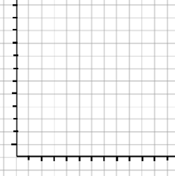

Does this relationship have a positive, negative, or no correlation?

Identify any outliers.

Identify any clusters.

