Name ____________________________________ Sect _____________
HW: Identify the y-intercept of the following tables:
X y x y x y
4 2 -10 0 -1 2
3 0 -5 2 0 .5
2 -2 0 4 1 -1
1 -4 5 6 2 -2.5
0 -6 10 8 3 -4

b = __________ b = ___________ b = ___________

Identify the y-intercept of the following graphs:
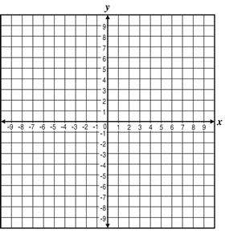
b = _____________ b = ________________

Identify the y-intercept from the following word problems:

Jalen starts the day with 8 pencils, and then finds one new pencil in each class.

b = __________________

There is 10 inches of snow on the ground, and it begins to melt at a rate of ½ inch per hour.

b = ___________________

